Report by: 1409046  
Role: Level Design & Artist liaison

Game Version: Latest – with Menus  
Date Reported: 10/04/2016

QA Status: Passed

Severity: Minor

Priority: Low

Test Introduction:

Here I wanted to test that the collider on the first object was working correctly. To test this, I ran the ship into the object the first object in-front of the model when you spawn.

Expected outcome:

I expected the ship object to be destroyed on contact with the model.

Actual outcome:

When I ran the game, the collision was much before the model of the object looking like the ship was just destroyed for no reason.

Screenshot of the bug:

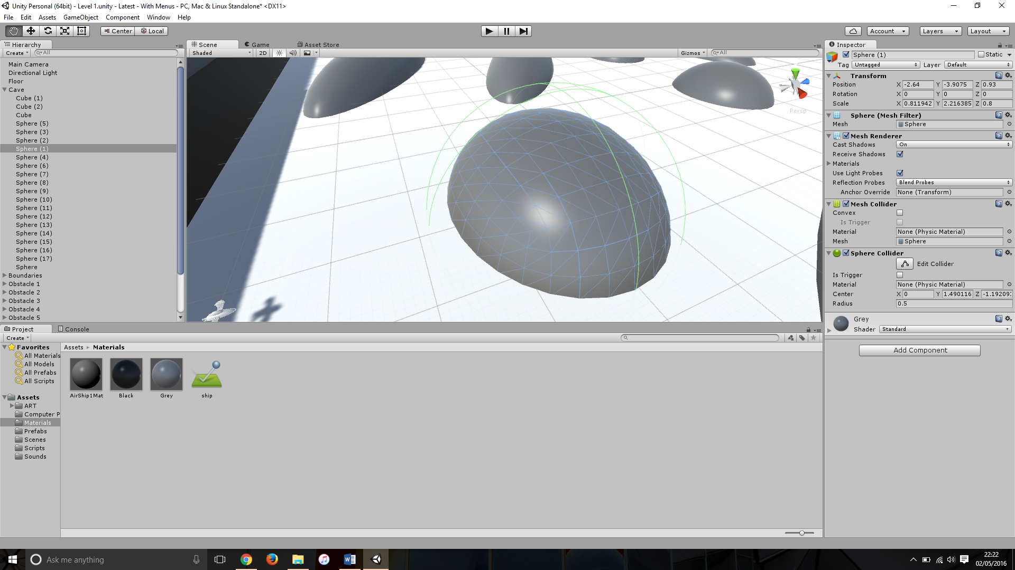

Image showing the collider not correlating with the sphere

Potential cause:

A potential cause of this could be the shape of the collider that was attached to the model.

Suggested Fix:

To fix this bug I had to add a mesh collider to each of the obstacles and remove the original sphere collider, as this had become excessively large due to the fact I had scaled the object in different directions.